Date access: 2020-03-09

<http://wjw.beijing.gov.cn/wjwh/ztzl/xxgzbd/gzbdyqtb/202001/t20200130_1621751.html>

As of 24:00 on the 23rd, 4 new cases of pneumonia caused by new coronavirus have been added to the city, with a total of 26 cases

Date: 2020-01-24 Source: Beijing Municipal Health Committee

From 14:00 to 24:00 on January 23, four new cases of pneumonia infected with new coronavirus were all male in the city, all of whom had a history of contact in Hubei. They were diagnosed and confirmed by CDC testing and expert assessment. Designated medical institutions for treatment.

As of 24:00 on the 23rd, a total of 26 confirmed cases were found in this city, including 3 in Xicheng District, 3 in Chaoyang District, 3 in Haidian District, 2 in Fengtai District, 1 in Shijingshan District, 2 in Tongzhou District, 1 in Shunyi District, There were 2 cases in Daxing District, 2 cases in Changping District, and 7 cases came from overseas.

**截至23日24时本市新增4例新型冠状病毒感染的肺炎病例，累计病例26人**

日期：2020-01-24 来源：北京市卫生健康委

       从1月23日14时至24时，本市新增4例新型冠状病毒感染的肺炎病例，均为男性，均有湖北接触史，经疾控中心检测和专家组评估确诊，均已送至定点医疗机构进行救治。

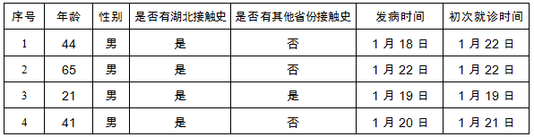

      截至23日24时，本市累计确诊病例26例，其中西城区3例、朝阳区3例、海淀区3例、丰台区2例、石景山区1例、通州区2例、顺义区1例、大兴区2例、昌平区2例，外地来京人员7例。